SIMATS ENGINEERING
ASSESSMENT TOOL 2

COURSE NAME: MLA03
COURSE CODE: Reinforcement learning for Environment and Agent

COURSE OUTCOME COVERED

CO1: Analyze reinforcement learning frameworks and Markov Decision Process concepts to model decision-making problems.( BL2,BL3)

Assessment Tool Weightage: 30%

Dr G. A. SENTHIL

QUESTIONS: 10 Total Marks: 50

Annexure A

Case Study Duration: 2hrs

- A logistics company is developing an RL-based warehouse robot that learns to pick, pack, and transport items efficiently while avoiding obstacles and minimizing delays. Analyze how the components of a Markov Decision Process (states, actions, rewards, policy, and environment) can be defined for this system. Design a reward function that balances speed, accuracy, and safety, and evaluate how reward design influences the robot’s learning and behavior. (5 Marks)

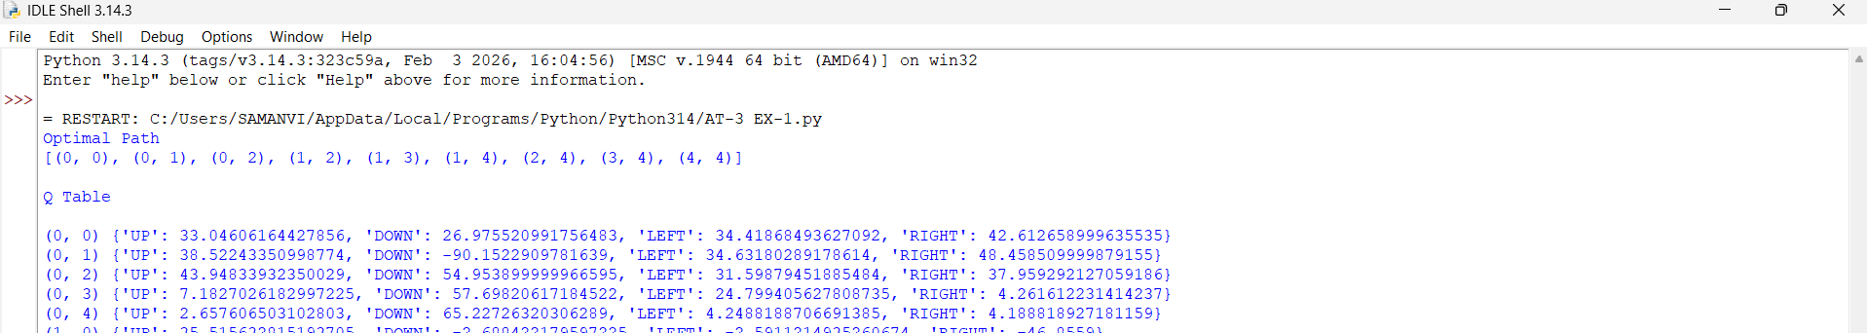
- A streaming platform wants to use Reinforcement Learning to recommend movies dynamically based on user preferences and viewing history. Apply RL concepts to construct a suitable state representation, action space, and reward function. Analyze how different reward signals affect user engagement and evaluate the trade-off between exploration and exploitation. (5 Marks)
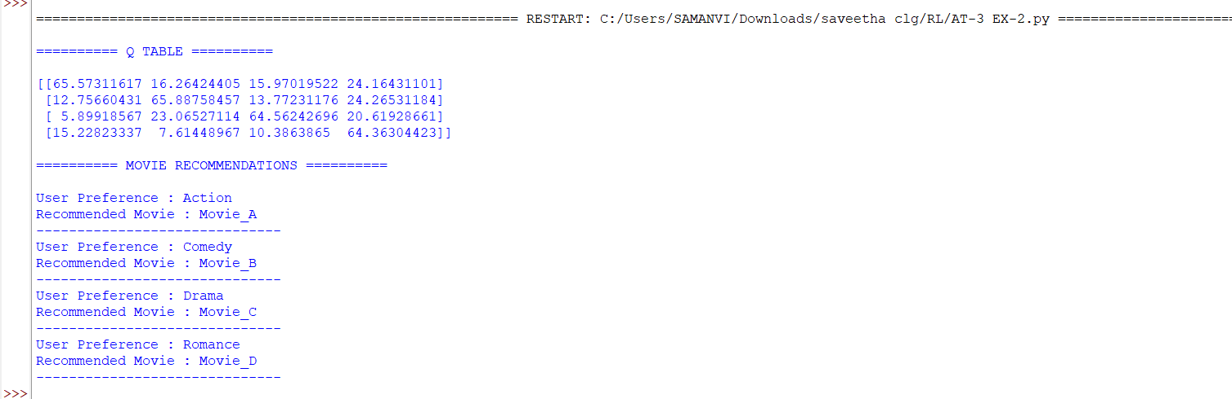
- An autonomous agricultural system uses RL to optimize irrigation and fertilizer usage based on soil conditions and weather forecasts. Design an RL framework by defining states, actions, and rewards. Analyze the effect of delayed rewards on crop yield optimization and justify the choice of a suitable learning algorithm. (5 Marks)
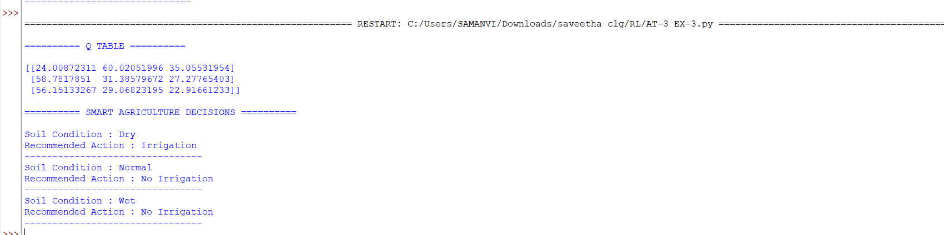
- A cybersecurity system uses RL to detect and respond to network attacks in real time. Analyze how states and environment can be modeled for intrusion detection. Design appropriate actions and reward functions, and evaluate the challenges of sparse rewards and real-time decision-making. (5 Marks)
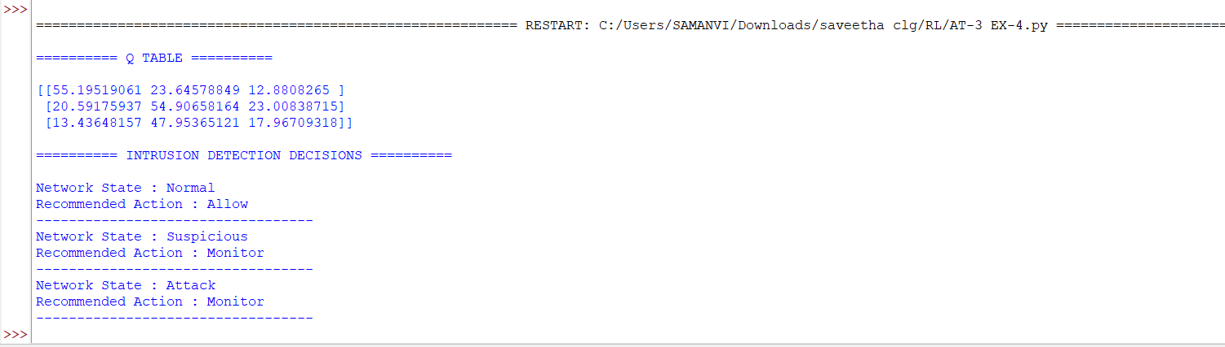
- A ride-sharing company plans to use RL to optimize driver allocation and dynamic pricing strategies. Apply RL concepts to define states, actions, and rewards. Analyze how environmental uncertainty affects learning and evaluate ethical concerns related to pricing strategies. (5 Marks)

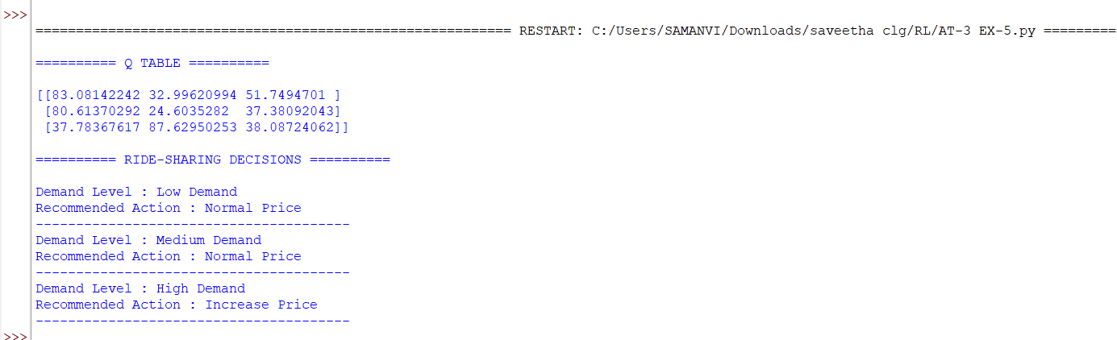
- A smart home automation system uses RL to control lighting, heating, and cooling based on occupancy and weather conditions. Design an RL framework including states, actions, and reward function. Analyze how conflicting objectives like comfort and energy saving can be handled and evaluate the impact of reward shaping. (5 Marks)
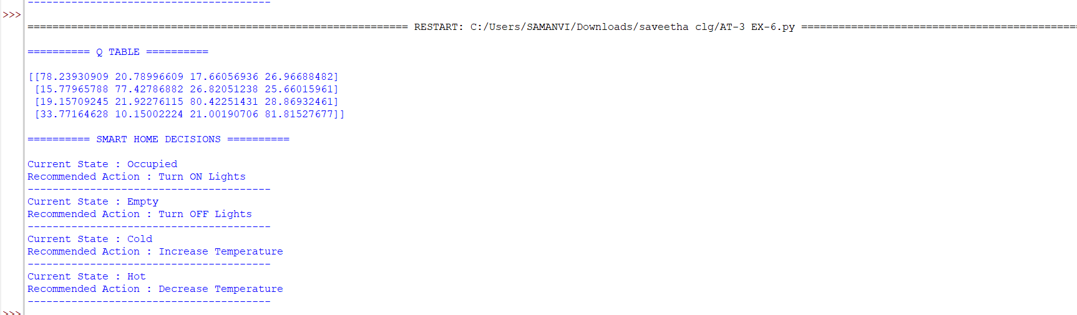

- A gaming company is developing an RL-based agent to play a complex strategy game against human players. Analyze how the problem can be modeled as an MDP. Design a reward structure that encourages long-term strategy and evaluate how exploration strategies affect performance.(5 Marks)
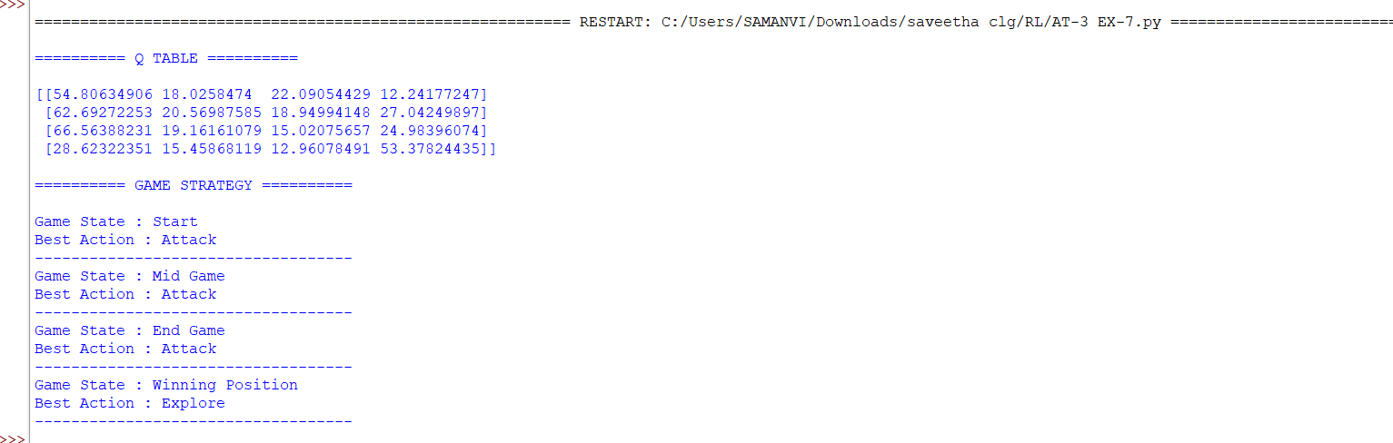
- A financial institution uses RL to detect fraudulent transactions in real time. Apply RL principles to define the state space, action space, and reward function. Analyze the challenges of imbalanced data and delayed feedback, and evaluate the risks associated with incorrect decisions. (5 Marks)
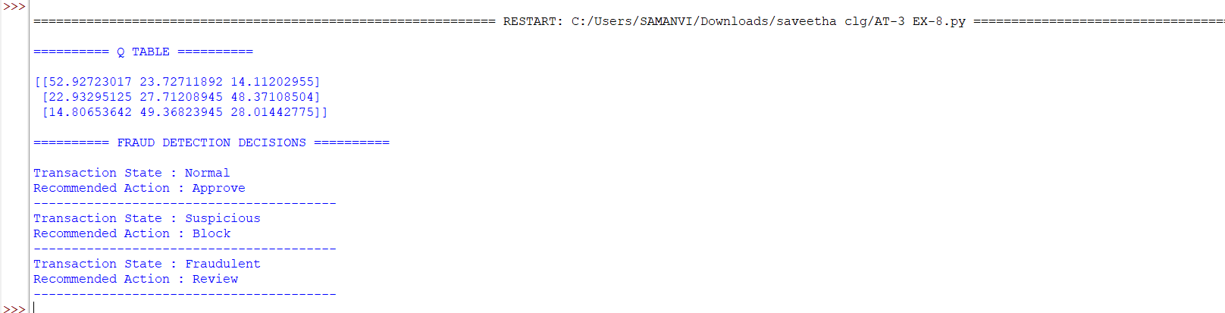
- A healthcare system uses RL to recommend personalized rehabilitation exercises for patients based on their progress. Design an RL framework with suitable states, actions, and rewards. Analyze the impact of delayed rewards and patient variability, and evaluate ethical concerns and safety considerations. (5 Marks)
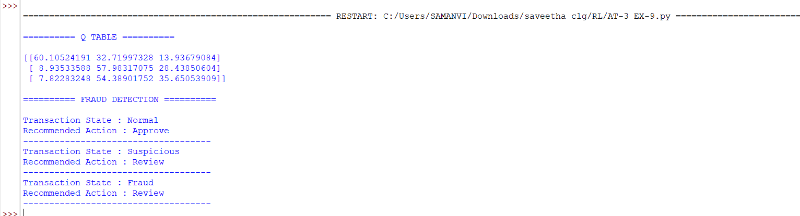
- A smart grid system uses RL to manage electricity distribution and reduce peak load demand. Analyze how the components of an MDP can be defined in this context. Design a reward function to balance efficiency and reliability, and evaluate the challenges of scalability and real-time learning. (5 Marks)
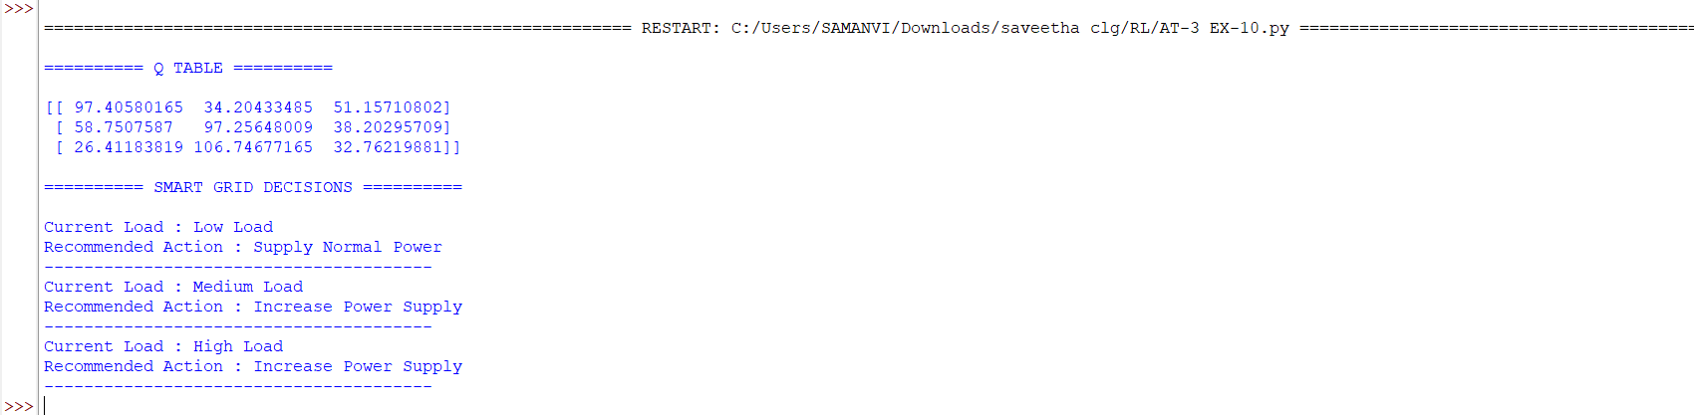

Code of Conduct:

I ____M.Samanvi (192425318)______ (Name / Reg No) certify that this submission is my original work and that I have adhered to the guidelines specified for this assessment.
I understand that any violation of academic integrity rules will result in disciplinary action.

Signature of the student: M.Samanvi

RUBRICS FOR CASESTUDY

Criteria | Weightage | Level 4 – Exemplary | Level 3 – Proficient | Level 2 – Developing | Level 1 – Beginning
Understanding of Case | 25 | Thorough understanding; clearly identifies all key issues | Good understanding with most issues identified | Basic understanding; some issues missed | Poor understanding; problem not identified correctly
Application of Concepts | 25 | Effectively applies relevant concepts to analyze the case deeply | Applies appropriate concepts with minor gaps | Limited application of concepts | Fails to apply relevant concepts
Analysis | 20 | In-depth analysis with strong reasoning and insights | Good analysis with logical reasoning | Basic analysis with limited depth | Weak or no analysis; lacks reasoning
Solution Design | 20 | Innovative, feasible solutions with strong justification | Logical solutions with adequate justification | Basic solutions with weak justification | Incorrect or no solution provided
Clarity | 10 | Clear, well-structured, and easy to understand | Organized and understandable presentation | Limited clarity and structure | Poor clarity; difficult to understand

